RingQ × Qontak CRM — User Guide
Oct 19, 2026 · @PM

What you get
With Qontak connected, every call in RingQ is looked up in Mekari Qontak CRM and saved there as a task, so your team sees who is calling and every call is on record without typing anything.
Feature | What your team sees
Contact popup | The caller's Qontak name, phone, email, company and owner next to the RingQ dialer while the phone rings.
Calls saved in Qontak | Every call (answered, missed, rejected, failed) becomes a Qontak task linked to the contact, with times, duration, talk time and agent.
Recording link | Answered, recorded calls get a link to the call recording inside the task.
AI transcription | Optional: the text of the conversation is added to the task.
Screen pop | Optional: Qontak opens automatically in a browser tab on the call's task or the caller's page.
Create contact | Optional: add an unknown caller to Qontak from the popup.
Setup at a glance (about 20 minutes, done once):
Step | Where | Who
1. Get Mekari Developer access | Mekari Developer Center | Qontak owner or admin
2. Create the application, copy Client ID and Client Secret | Mekari Developer Center | Qontak owner or admin
3. Connect Qontak | RingQ → Global Settings → Integrations → CRM | RingQ admin
4. Turn on AI transcription (optional) | RingQ → Global Settings → AI transcription | RingQ admin
5. Allow pop-ups and test | Agent's browser | Each agent

Before you start
Tick these first; if one is missing, the steps below will stop at that point.
- ☐ Your company has an active Qontak CRM subscription.
- ☐ You know the Qontak owner or admin login (the Mekari account email and password).
- ☐ Each agent who makes calls exists as a user in Qontak (added by your Qontak admin), so tasks and contacts show the right owner.
- ☐ You can sign in to RingQ as an admin (only admins see and change integration settings).
- ☐ Your RingQ provider has enabled the Qontak integration: Global Settings → Integrations → CRM shows a Qontak card.
- ☐ Agents use Google Chrome or Microsoft Edge.
- ☐ For recording links and AI: call recording is on for the agents' extensions or queues.

Step 1 — Sign in to the Mekari Developer Center
The Client ID and Client Secret come from the Mekari Developer Center (not from the Qontak app itself); you sign in there with your normal Mekari / Qontak account.
- Open developers.mekari.com in Chrome or Edge.
- Click Sign in and use your Mekari account: the same email and password you use for Qontak. Use an account that can access your company in Qontak (the owner or an admin).
- Look at the dashboard you land on:
You see | Means | Go to
A Create Application button at the top, near the header | Your account is authorised | Step 2, Option A
An empty page | Your account is not authorised yet | Step 2, Option B

Step 2 — Get the Client ID and Client Secret
You need two values, Client ID and Client Secret (Mekari calls them HMAC credentials); create them yourself in the Developer Center (Option A) or ask Mekari to issue them (Option B).
Option A — create them yourself (dashboard shows Create Application)
- On the Mekari Developer dashboard, click Create Application (top of the page, near the header).
- Fill in the three fields:
Field | Enter
Application Name | RingQ Phone System
Company | Your Qontak company (one application per company)
Authorized Scopes | Tick only the Qontak CRM scopes for contacts, tasks and task categories
- Click Submit.
- Your Client ID and Client Secret appear on the next page. Copy both now into a safe place, such as a password manager. The Client Secret is shown only on this page and can't be viewed again.
Option B — ask Mekari to issue them (empty dashboard, or no Create Application button)
Mekari still creates HMAC credentials through support for many accounts. Send this to your Qontak account specialist or Mekari support:
Please create Mekari HMAC API credentials (Client ID and Client Secret) for our company [your company name] for the Qontak CRM API, with scopes for contacts, tasks and task categories. We are connecting our RingQ phone system.
Mekari either sends you the Client ID and Client Secret, or authorises your account so you can follow Option A.
Good to know
- One pair of credentials works for one company and one Mekari product (here: Qontak CRM).
- Live Qontak = Production. Sandbox credentials (for testing) are separate; Mekari tells you which you have.
- Lost the Client Secret? Create new credentials (Option A again, or ask Mekari), then enter the new pair in RingQ.
- Never share the Client Secret by chat or email if you can avoid it; it is entered only once, in Step 3.
Sources: Mekari — Create Application · Mekari — HMAC Authentication

Step 3 — Connect Qontak in RingQ
A RingQ admin enters the two values once; RingQ stores the secret encrypted and never shows it again.
- Sign in to RingQ as an admin.
- Go to Global Settings → Integrations → CRM.
- On the Qontak card, click Configure. The Qontak CRM settings window opens.
- Turn on Enable Qontak integration.
- Under API credentials:
  - Environment: choose Production (api.mekari.com) (or Sandbox (api.mekari.io) for test credentials).
  - Client ID: paste the Client ID.
  - Client Secret: paste the Client Secret.
  - Acting CRM user SSO ID: leave empty.
- Click Test connection. You should see "Connected to Qontak CRM successfully."
- Check the other options (see Every option explained); the defaults suit most teams.
- Click Save configuration. You should see "Qontak settings saved." next to the button.
- The window's status now says Connected, and the Qontak card shows Enabled.
- Ask every agent to press Ctrl+F5 once in RingQ so the new settings load.
If Save shows "Not saved. Please fix: …", the window scrolls to the field that needs correcting. When you change settings later, leave Client Secret empty: the stored secret is kept.

Step 4 — Turn on AI transcription (optional)
Qontak uses RingQ's own transcription, the same one behind Call Logs → Transcribe, so turn that on first.
- In RingQ go to Global Settings → AI transcription.
- Turn transcription on and choose the engine:
  - RingQ AI: pick a model; tiny is the fastest.
  - OpenAI: paste your OpenAI API key.
- Save.
- Check it works: open Reports → Call logs, find a recorded call and click its Transcribe icon. Text should appear.
- Back in Integrations → CRM → Qontak, turn on AI transcription under AI call intelligence (optional) and click Save configuration.
From now on, after each answered, recorded call the transcript is added to the Qontak task automatically, usually within seconds to a minute depending on the call length and engine.

Step 5 — Allow pop-ups and make a test call
Each agent does this once in their browser; then one test call confirms everything works.
Allow pop-ups (needed only for screen pop):
- Open RingQ in Chrome or Edge.
- Click the pop-up icon at the right end of the address bar (or the lock icon → Site settings).
- Choose Always allow pop-ups and redirects from your RingQ address, then Done.
Test call:
- Call a number that belongs to a contact in Qontak.
- The contact popup appears next to the dialer with the contact's details.
- Talk for a few seconds, then hang up.
- The popup's Qontak log shows Synced and "Call saved to Qontak with recording link."
- With AI on: "Transcribing the call…", then a Transcription section appears.
- In Qontak, open Tasks: a new task "Outbound call - Answered - … - RQ…" is there, linked to the contact.
All six happen → the setup is complete.

How it works
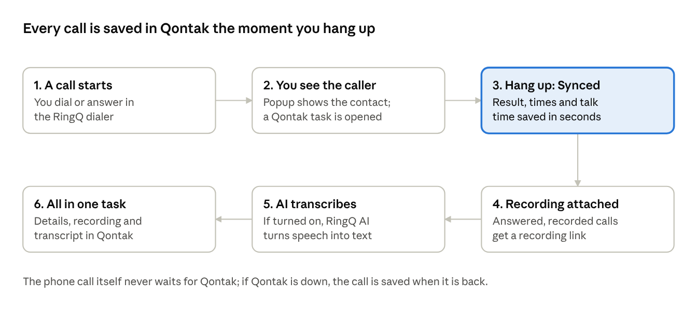
one call · 6 steps from dial to Qontak task
Steps 1–3 happen for every call; steps 4–5 only for answered, recorded calls (and step 5 only with AI transcription on). All of them update the same Qontak task.

Every option explained
The options below appear in the Qontak CRM settings window in this order; the defaults work for most teams, so change only what your team needs.
Where: RingQ → Global Settings → Integrations → CRM → Qontak card → Configure. Only admins can change these options; scroll down inside the window to see them all. The four screenshots below show the whole window from top to bottom.
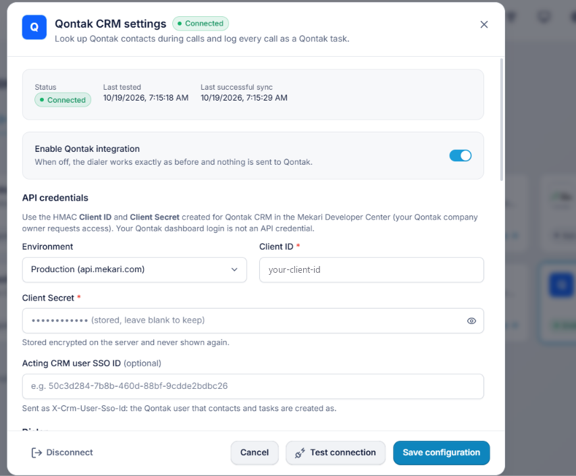
Screen 1 — top of the window: status, Enable switch, API credentials.
Status (top of the window)
Shows | Meaning
Connected | Credentials work and the integration is on.
Disabled | Credentials are saved but Enable is off; nothing is sent to Qontak.
Connection error | Qontak refused the credentials or is unreachable; Last error says why.
Not configured | No credentials saved yet.
Last tested / Last successful sync | When the connection was last tested, and when a call was last saved to Qontak.
Main switch and credentials
Option | Default | What it does | When to change
Enable Qontak integration | Off | Master switch. Off: the dialer works exactly as before and nothing is sent to Qontak. | Off to pause the integration without losing the credentials.
Environment | Production | Which Mekari API to use: Production (api.mekari.com) for live Qontak, Sandbox (api.mekari.io) for testing. | Only with sandbox credentials.
Client ID | — | Your application's Client ID from Step 2. | When Mekari issues new credentials.
Client Secret | — | Your Client Secret. Stored encrypted and never shown again; leave empty to keep it. | When Mekari issues new credentials.
Acting CRM user SSO ID | Empty | The Qontak user that contacts and tasks are created as. | Only if Mekari or your provider tells you to.
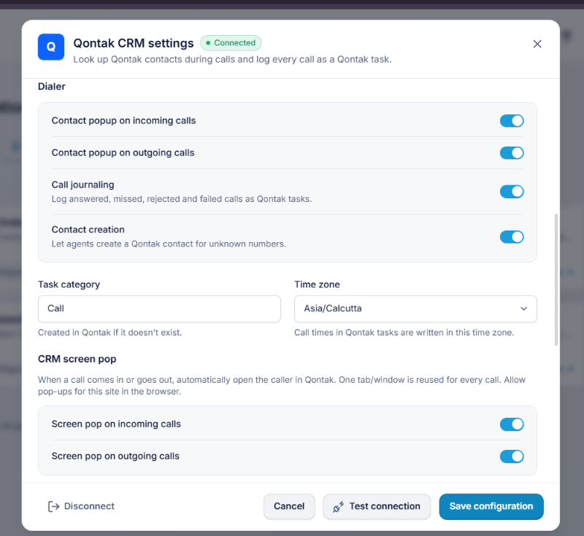
Screen 2 — Dialer options, task category and time zone.
Dialer
Option | Default | What it does | When to change
Contact popup on incoming calls | On | Shows the caller's Qontak contact next to the dialer when a call rings. | Off if agents don't want the panel.
Contact popup on outgoing calls | On | Same when an agent dials out. | Off if not wanted.
Call journaling | On | Saves answered, missed, rejected and failed calls as Qontak tasks, with recording link. | Off to look up contacts only, without saving calls.
Contact creation | Off | Shows Create contact in the popup for unknown numbers. | On if agents may add new contacts to Qontak.
Task category | Call | The Qontak task category used for call tasks; created in Qontak if it doesn't exist. | To match your own Qontak category name.
Time zone | Your computer's | Time zone used for the call times written in Qontak tasks. | Set to your office, e.g. Asia/Jakarta.
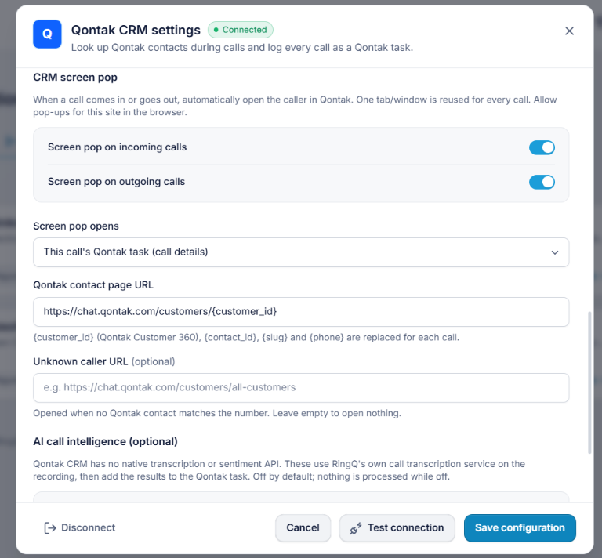
Screen 3 — CRM screen pop.
CRM screen pop
Option | Default | What it does | When to change
Screen pop on incoming calls | Off | Opens Qontak automatically in a browser tab when a call comes in. One tab is reused for every call. | On for agents who work in Qontak during calls.
Screen pop on outgoing calls | Off | Same when dialling out. | On if wanted.
Screen pop opens | This call's Qontak task | This call's Qontak task (call details): Qontak's task list showing only this call's task; one click opens it. Qontak customer page: the caller's page in Qontak. RingQ call-details window: a small RingQ window with the live call and contact. | Choose what agents should see first.
Qontak contact page URL | https://chat.qontak.com/customers/{customer_id} | Address of the caller's Qontak page; also used by Open in Qontak. Leave as is or empty for this default. | Only if Qontak changes its addresses.
Unknown caller URL | https://chat.qontak.com/customers/all-customers | Opened when no Qontak contact matches the number. Empty = open nothing. | Change or clear as you prefer.
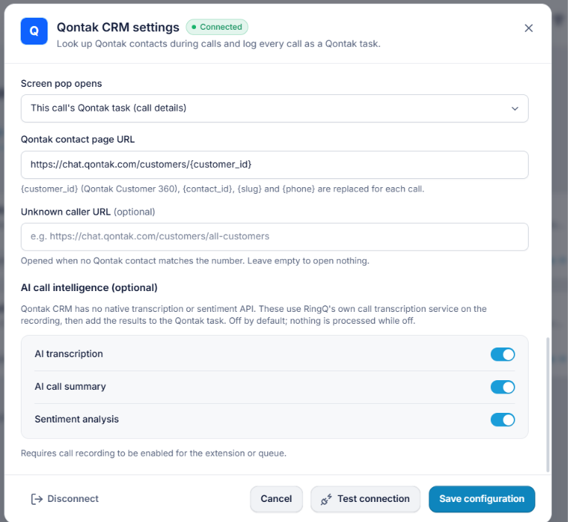
Screen 4 — AI call intelligence and the buttons at the bottom.
AI call intelligence (optional) — needs call recording on for the extension or queue.
Option | Default | What it does | When to change
AI transcription | Off | Adds the call's transcript to the Qontak task (and to RingQ Call Logs). | On after Step 4.
AI call summary | Off | Reserved for a future summary feature; nothing is added today. | Leave off.
Sentiment analysis | Off | Reserved for a future sentiment feature; nothing is added today. | Leave off.
Buttons
Button | What it does
Test connection | Checks the credentials with Qontak without saving.
Save configuration | Saves all options (and tests the connection).
Disconnect | Deletes the stored credentials and stops saving calls; existing call logs are kept. Asks for confirmation.
Cancel / ✕ | Closes without saving.
Recommended settings for most teams
Option | Set to
Enable Qontak integration | On
Environment | Production (api.mekari.com)
Contact popup on incoming / outgoing calls | On / On
Call journaling | On
Contact creation | On if agents may add contacts, else Off
Task category | Call
Time zone | Your office time zone (e.g. Asia/Jakarta, Asia/Kolkata)
Screen pop on incoming / outgoing calls | On for agents who work in Qontak, else Off
Screen pop opens | This call's Qontak task (call details)
Qontak contact page URL | https://chat.qontak.com/customers/{customer_id} (default)
Unknown caller URL | Empty (opens nothing), or https://chat.qontak.com/customers/all-customers
AI transcription | On, after Step 4
AI call summary / Sentiment analysis | Off: switching them on does nothing yet
After any change, click Save configuration, and agents press Ctrl+F5 once.

Using it every day
Agents keep using the RingQ dialer as usual; the popup and Qontak update on their own.
Contact popup (top part)
Popup shows | What to do
The contact's card | Nothing; the call is saved to this contact. Open in Qontak opens their page.
"No Qontak contact matches …" | Unknown number. If allowed, click Create contact, enter a first name and save.
A list of contacts | Several contacts share the number; click the right one.
"Qontak is unreachable. The call is not affected." | Click Retry; the call itself is never affected.
The popup can be minimised or closed; it never covers the call buttons.
Qontak log (bottom part, after hang-up)
Shows | Meaning
Logging call to Qontak… | Saving; normally 1–2 seconds.
Synced · Call saved to Qontak | The task has the final result. "with recording link" = the recording is attached.
Transcribing the call… | AI is writing the transcript; it is added to the same task.
Transcription ▾ | Click to read the transcript.
AI analysis not available: reason · Retry AI | AI could not run (e.g. transcription off in RingQ). Fix the reason, then Retry AI (admins).
Failed + reason · Retry | The call could not be saved; Retry sends it again. Calls are also retried automatically.
Finding calls in Qontak
- Open Tasks and filter by category Call, or open the contact and look at its tasks.
- Task name: direction - result - contact (number) - agent - RQ reference, e.g. "Inbound call - Missed - Sathiyan (1004) - Paramesh - RQ1a2b3c4d".
- Missed calls are Not Started tasks, a ready-made call-back list; answered calls are Completed.
- The task details hold direction, result, agent and extension, start, answer and end times, duration, talk time, Recording URL (copy it into a browser to play the call) and the transcript.
Screen pop
With screen pop on, Qontak opens in a browser tab when a call starts; the same tab is reused for every call. With This call's Qontak task, the tab shows only this call's task; click it to open the details.

Troubleshooting and FAQ
The window and popup always say what went wrong; find the message below.
Message or problem | What to do
Test connection: "Qontak rejected the credentials (HTTP 401)" | Re-copy the Client ID and Secret; check Environment (Production vs Sandbox); if the secret is lost, create new credentials (Step 2).
"The Qontak credentials lack permission (HTTP 403)" | In the Mekari Developer Center, give the application the Qontak CRM contacts and tasks scopes.
"Unauthorized" or "Could not reach the server" in the window | Contact your RingQ provider (server setup).
"Not saved. Please fix: …" | Correct the field the window scrolls to, then save again.
No popup during calls | Check Enable, Contact popup options and Save; agents press Ctrl+F5.
Screen pop does not open / "Your browser blocked the Qontak pop-up" | Allow pop-ups for RingQ (Step 5); check the screen pop options.
No recording link | Only answered calls with recording on get one; ask your admin to enable recording.
"AI analysis not available: AI transcription is turned off in RingQ" | Do Step 4, then Retry AI.
Transcript takes long | It depends on call length and AI engine; RingQ AI model tiny is fastest.
Qontak's "Associated" column is empty | Normal: Qontak shows only a company or deal there. The task is linked to the contact (see the task's Associated Records).
Outbound busy calls show "No answer" | Expected: the browser dialer doesn't report busy for outbound calls.
Does the dialer depend on Qontak? No. If Qontak is down, calls work normally and are saved automatically when Qontak is back.
Can agents see the Client Secret? No. Only admins can change settings, and the secret is never shown again.
Do we need one application per agent? No. One application per Qontak company covers all agents.
Can we try it without touching live Qontak? Yes: use Sandbox credentials from Mekari with Environment = Sandbox.

Security, disconnecting and support
Your credentials and recordings stay protected, and you can switch the integration off at any time.
- Credentials: the Client Secret is stored encrypted on the RingQ server, never shown again and never sent to agents' browsers.
- Recording links: each link is signed and works for that one call only; it cannot be changed to reach another recording.
- What is sent to Qontak: phone-number lookups and one task per call (call details, agent, recording link, optional transcript). Nothing else.
- Pause: turn off Enable Qontak integration and save; credentials are kept.
- Disconnect: click Disconnect and confirm. RingQ deletes the credentials, stops saving calls and switches off all recording links already in Qontak. RingQ's own call history is kept.
- New credentials: create them in the Mekari Developer Center, paste the new Client ID and Secret, Save configuration.
Support: RingQ settings and calls → your RingQ provider. Qontak account, Mekari Developer access or credentials → your Qontak account specialist or Mekari support.

